All of the following prices are for using premium grade tanalised timber painted using Profilan Impra Opac paint. Our prices include everything you see - from foundations to finials, including guttering and shelving. There are no hidden extras. Although an extra charge may be necessary to cover a very long journey as I make my way to Cornwall, Inverness, Felixstowe, Brighton etc.
Want something different - just ask. This is only a selection of many available sizes and designs.

 | Name | Size | Tanalised pine
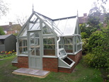 | Yvonne | 3.7m long x 3.5m wide with porch & cold frames | £11,940 + VAT (Total 14,328) | £15,125 +VAT  (Total £18,150)
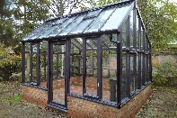 | Henry | 4m long by 3.5m wide duo-pitch, modern style | £12,850 + VAT (Total 15,420) | £17,460 +VAT  (Total £20,952)
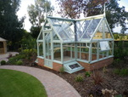 | Miriam | 4.3m long x 3.5m wide with porch & cold frames | £11,800 + VAT (Total 14,550) | £15,690 +VAT  (Total £18,828)
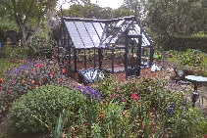 | Mark | 5m long x 3.5m wide with porch & cold frames | £13,040 + VAT (Total 15,648) | £17,010 +VAT  (Total £20,412)
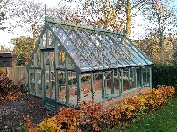 | Julien | 5m long x 3m wide with side windows | £12,160 + VAT (Total 14,592) | £15,275 +VAT  (Total £18,330)
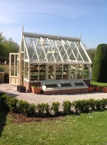 | Jill | 4m long x 2.8m wide with side windows & cold frames | £12,130 + VAT (Total 14,556) | £15,100 +VAT  (Total £18,120)
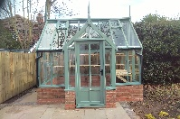 | Steve | 3.5m long x 3m wide with low porch | £11,880 + VAT (Total 14,256) | £15,080 +VAT  (Total £18,096)
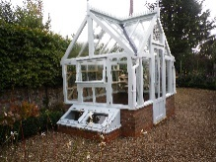 | Sarah | 2.2m wide x 2.8m long with cold frames | £11,090 + VAT (Total 13,308) | £13,250 +VAT  (Total £15,900)
 | Mike | 2.2m wide x 2.8m long with internal raised bed and brick pathway | £11,090 + VAT (Total 13,308) | £13,250 +VAT  (Total £15,900)
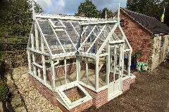 | Tim | 3m wide (including porch) by 4m long with a reduced height porch. | £12,100940 + VAT (Total 14,520) | £15,200 +VAT  (Total £18,240)
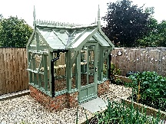 | Richard | 1.5m wide by 2.5m long and 2.5m high | £10,280 + VAT (Total 12,336) | £12,700 +VAT  (Total £15,240)

